*draft mode* not ready
Moai Calibration Check

The purpose of this guide is to verify if hardware is installed correctly and set up for printing. This guide does not deal with dimension accuracy and that is covered in a separate guide.

*Please make sure Moai is placed on a sturdy and level surface before begin working.

**FEP Vat users, most of the information still applies to you. If there is a special instruction needed for you, it will be in this green font.

These are the check steps in the order which you will do:

- Power On
- Setting Check
- Galvo Scanning Test
- Leveling
- Test Print
Please do not pour resin into vat until the instruction tell you so or it will make testing more difficult.

Moai is shipped with galvos and plate calibrated to work together. To make sure everything is still working after delivery, we will run three tests:

- Power on Check
DO NOT INSTALL BUILD PLATE OR PUT ANY RESIN INTO VAT for calibration test

Click the Power Switch on the Front Panel to Turn on the Machine (pic)
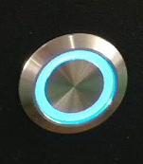
Two things to look for here:
- The Z Axis will raise to the top and stop at the end stop sensor
- The Vat holder will run to the top of the travel (the clicking sound is normal) and then perform a tilt action and then return to the level position
You should see this screen when Moai is ready:
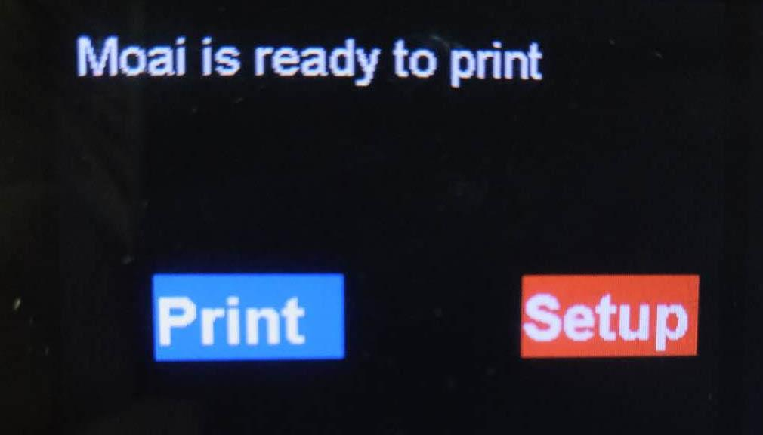
- Setting check
Use the Control Knob above the Power Switch to move between “Print” and “Setup”
Press the knob to enter “Setup” (Double press to go back)
Please check your setting and adjust to match the picture below:
If the settings do not match, you can select and click on each entry to adjust the value to match the default values.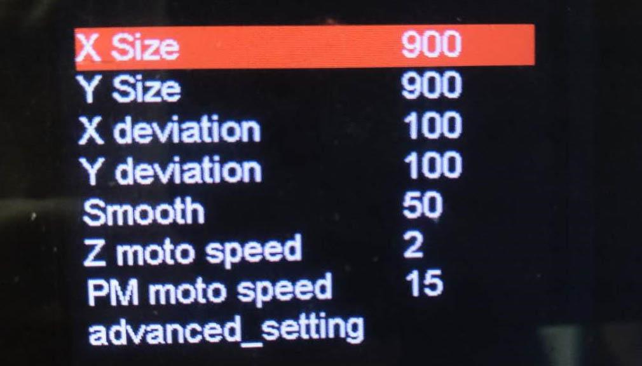
Then use the Control Knob to scroll down to advanced_setting and click to the next screen. Check to see if the settings match this screen also.
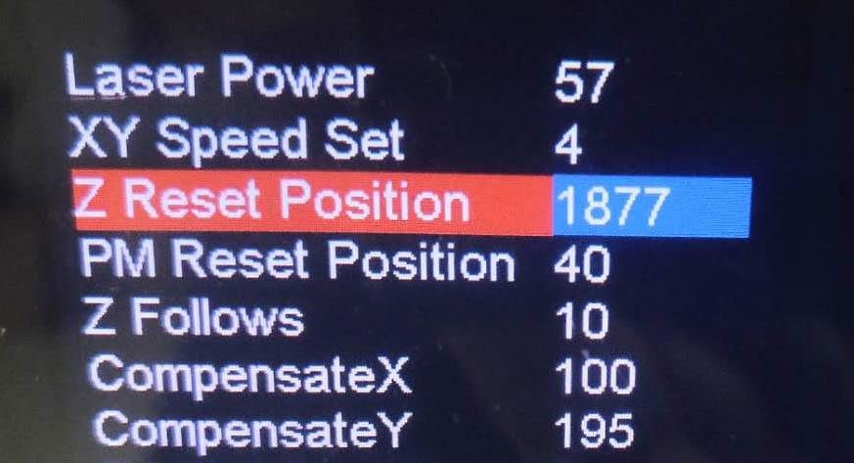
Laser power is a key setting. We like to set it around 57-58 for Peopoly standard resin. Please check against that. Non-Peopoly resin may need to have a lower or higher laser power.

*For FEP Vat users. The Z Reset Position should be 1816
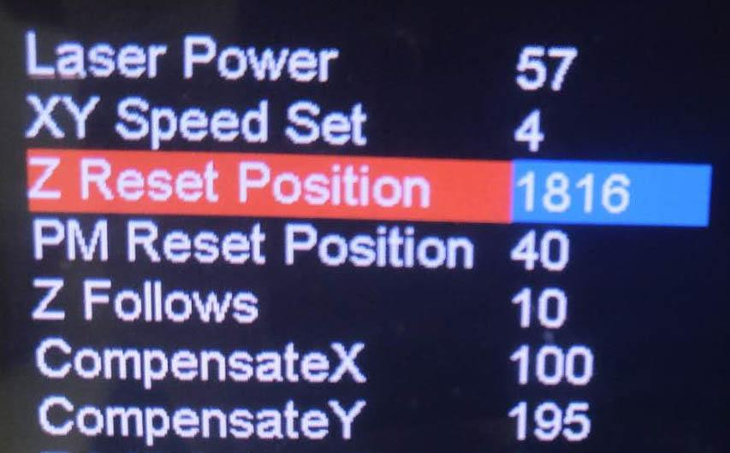

- Galvo test

Please download following files

calibration-circle.pdf: https://drive.google.com/open?id=0Bzke6lBHG_z5MkhwQjZ0bk5UaXM
(This file is also located in your SD card’s pdf directory)

https://drive.google.com/open?id=0Bzke6lBHG_z5NmdFUmZENDZ0OEk
(This file is also located in your SD card’s gcode directory)

Print the calibration-circle.pdf and cut it to the outer square and place it in the Vat.
Insert the vat with the printed calibration-circle into the Moai.

NOTE: Make sure the Calibration Circle PDF is printed at 100% scale, do not use the Fit to page option. The dimensions of the printed box should be 5-1/8" (130.18mm), and the largest circle should be 120mm diameter.

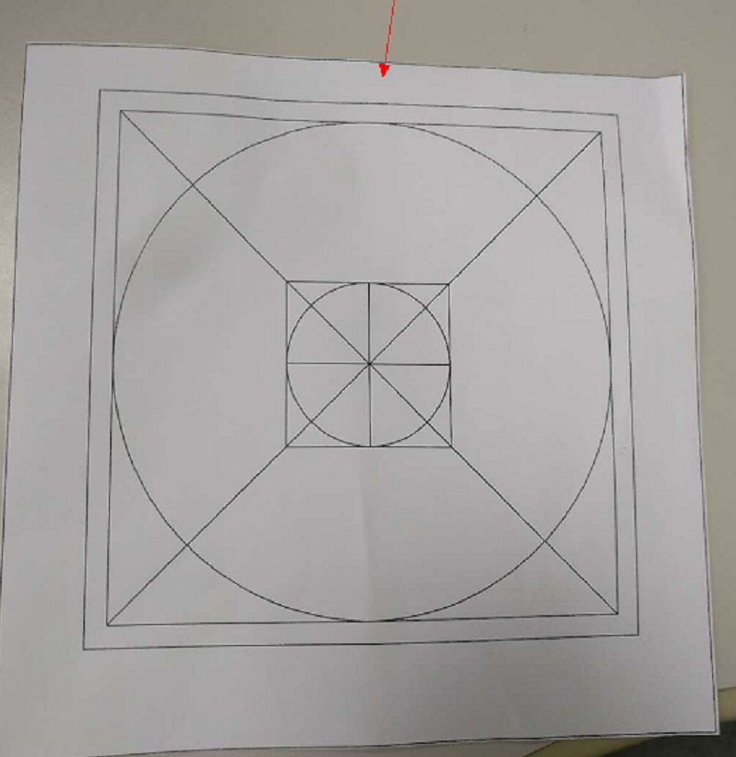
Note how the inside squares and circles are shifted. The side with the narrow spacing should be to the back of the Moai nearest to z-axis linear rail when the vat is installed.

* For FEP vat users, use a specially made calibration file call calibration-circle FEP.pdf
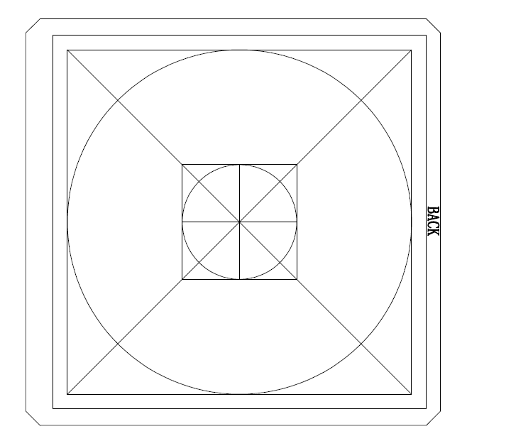

Circle test Gcode:
Extract P_yuan-test.gcode from P_yuan-test.zip and place the GCode file in directory called “gcode” in a SD card.

Insert the included SD Card in the Machine (make sure you insert with the back of SD card facing up):
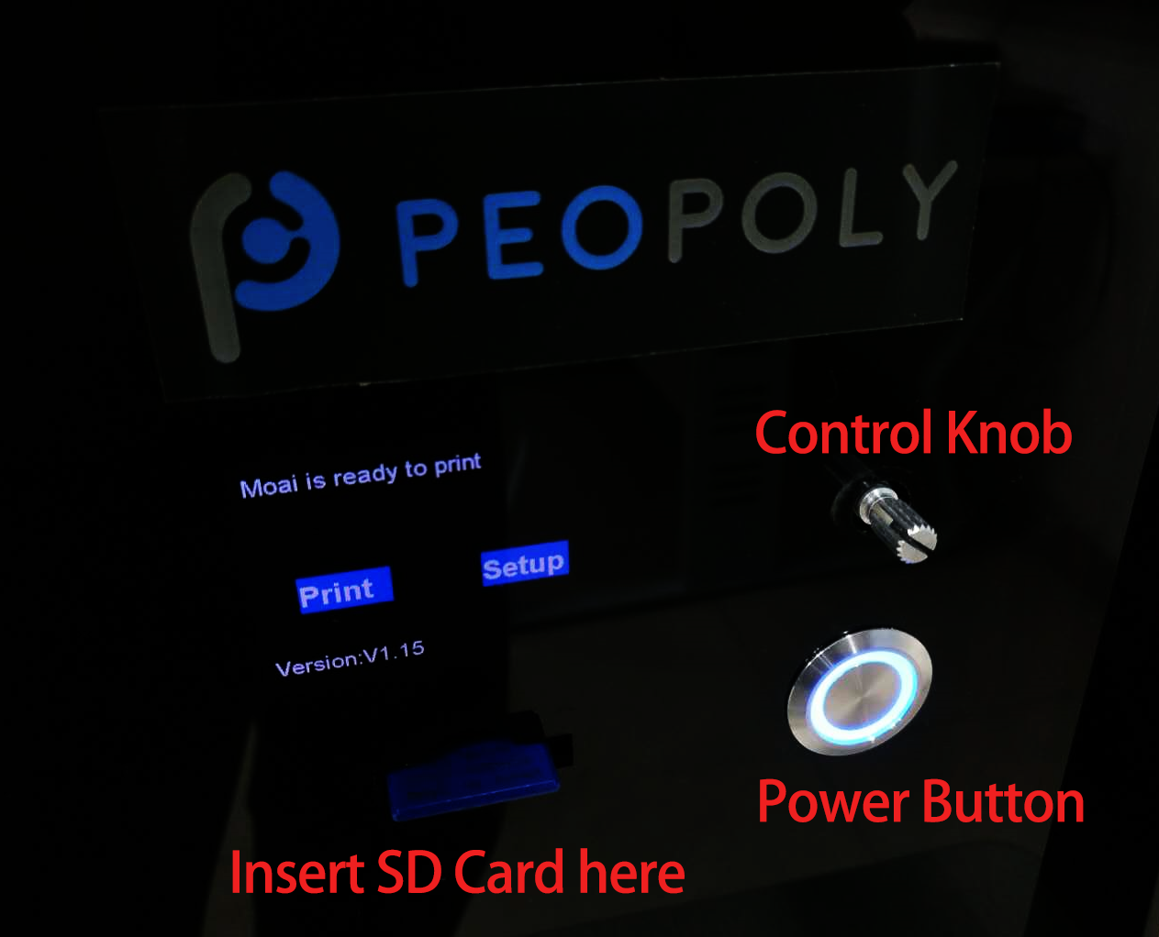

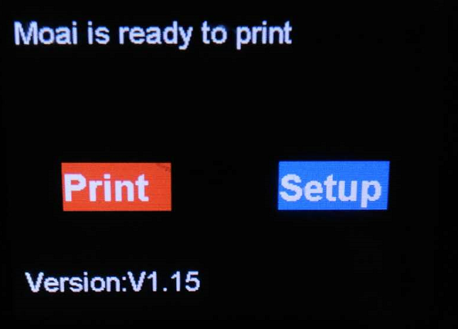
Select Print from the Moai’s menu and Click Confirmed.

You should see Z-Axis drops the Build Plate arm, tilt the Vat and begin to scan like below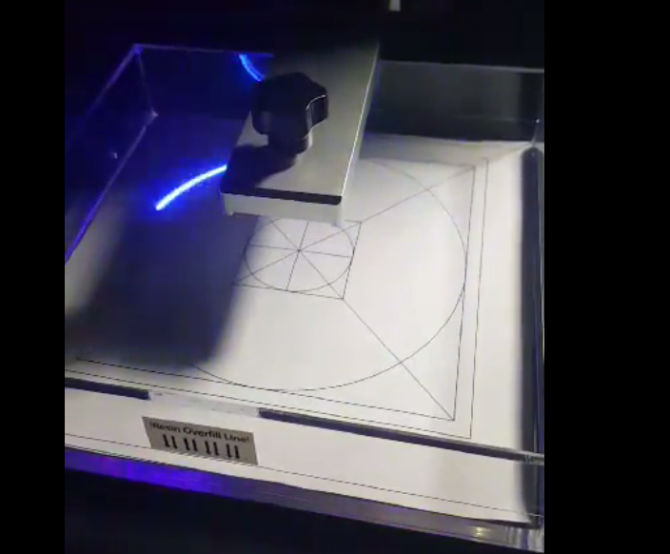

Video: https://youtu.be/4jeJfWrDAyI

Move the paper slightly such that the circle overlaps with the laser scanning path

For additional help, use this calibration video: https://www.youtube.com/watch?v=gHHqfrhKt7M

Leveling

Since Peopoly built Moai kit to test print before shipping, the leveling should already be close to optimal. Following steps are to help you check leveling and make small changes if needed.

You should run the leveling check again when you change vats

Steps

1. Download this gcode and placed it in the SD card’s Gcode directory
https://drive.google.com/file/d/1REhwgXPzffKO1UOH15q6oeZvWlj-A3Lv/view

You will find this gcode
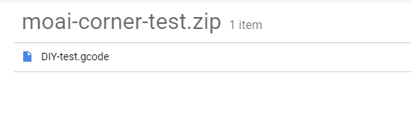
2. Install build plate on Moai and make sure the knob is tightened.
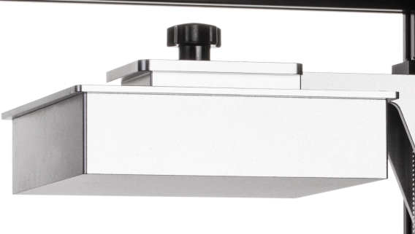

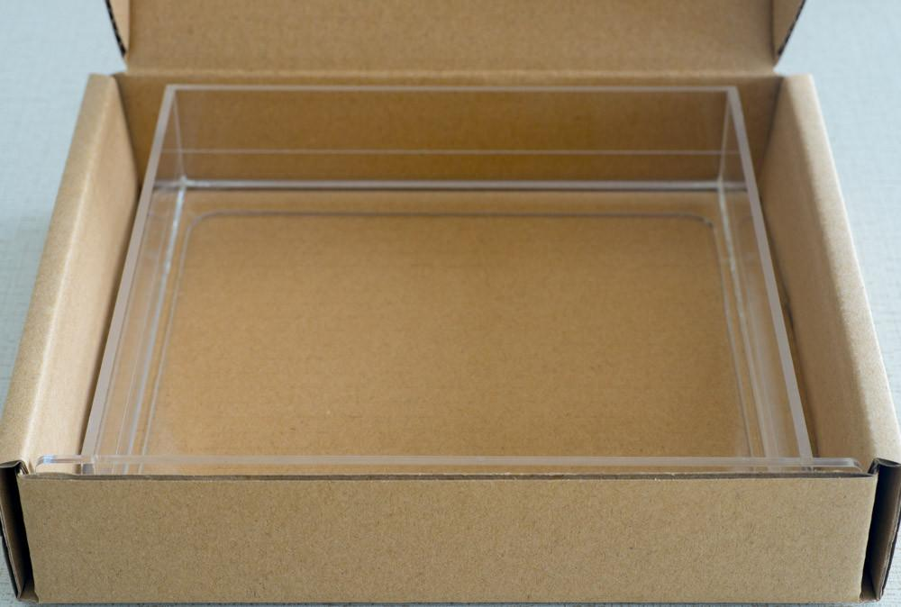

3. Locate the resin vat package and take out the vat. Make sure not to touch the bottom part of the vat.
4. Take out the resin bottle that looks like this:
Shake well (for about 30 seconds) before you open it and then pour resin into the vat:

The printer setup would look like: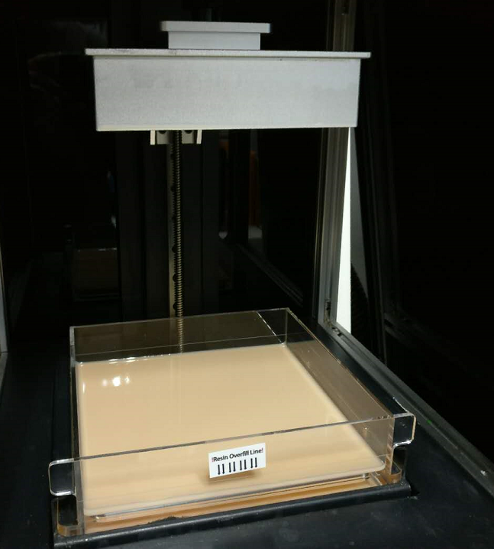
-

5. Now insert the SD card in to the Moai and power it on by pressing the power button.

Print the gcode by using the control knob to
- select print
- Select gcode directory
- Select DIYTest.gcode file

This print takes about 20 minutes.
This gcode contains 4 small cylinders with one at each corner of the built plate labeled as A, B, C, and D. see following pictures in Cura:
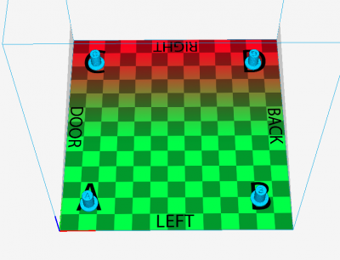

The lettering represents their location on the built plate. This helps you identify them when they are removed from the build plate.
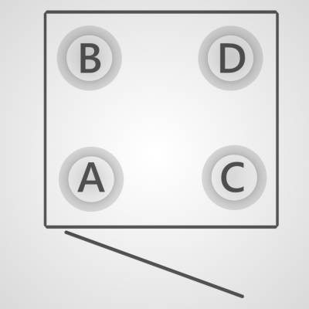

The way to use these cylinders is that we want the printed cylinders to have a height of 10.6-10.8mm. The height of the cylinder tells us how much pressure is placed on the PDMS layer.

When the print is finished. They should look like this when build plate is facing up to the ceiling:
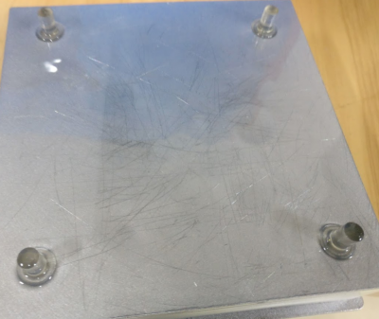
Check location by removing and cleaning (using Ethanol or IPA) one at the time and match them to this picture. If they don’t match, make sure you are holding the plate in the right direction.

Once you got all 4 cylinders removed and cleaned from the plate, go ahead and measure their heights and marked them by A, B, C, D.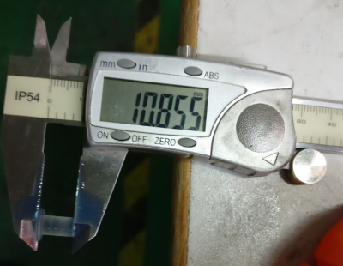

For example, you may have A 10.4mm B 11.0mm C 10.65mm D 10.0mm
This set of numbers represents how your Moai is leveled. You can use it to help you get to optimal level (10.6 – 10.8mm) and share with those who are trying to assist you.

To adjust, first find the tools for adjustment. Locate this screwdriver from accessory box.
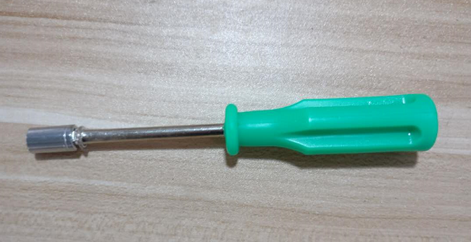

Then you have to remove the left and right panels and to look under the build platform and find the nuts like these.

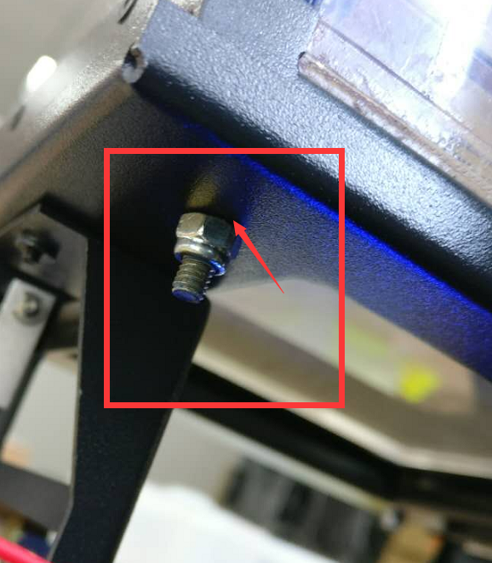

There is one under each corner under the vat holder. The amount of adjustment to each nut is based on the difference between current cylinder height. This diagram can help you visualize better.
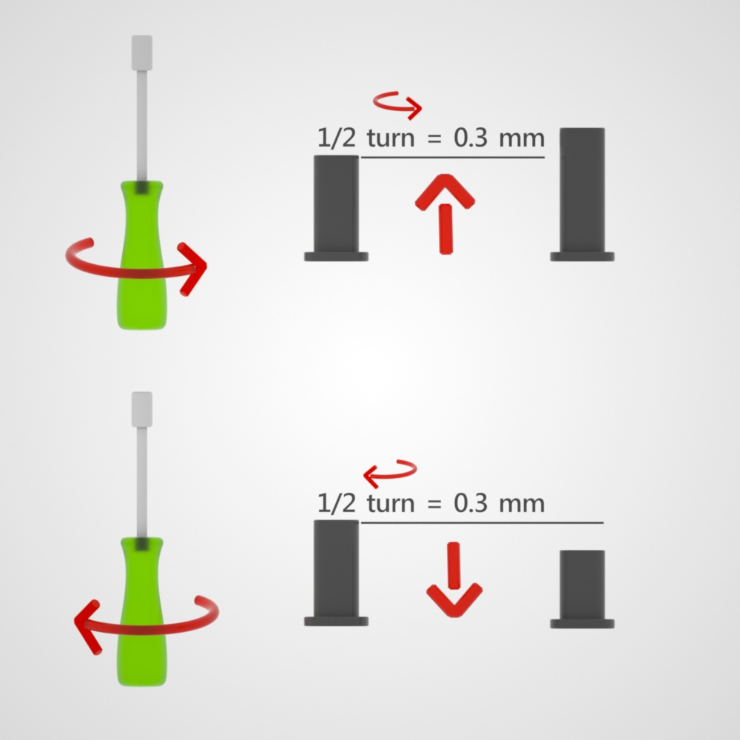
Using above measurements as example
To adjust A corner, find the nut under A’s corner and turn it.
Since A is off by 10.4 – 10.75 = 0.35mm. half turn tightening is 0.35mm increase in cylinder height. You make 1 half turn, and we can ex
B corner cylinder is 11mm. We can do half turn loosening of the nut to decrease the height by 0.35mm. Turning it to 10.65mm
C corner cylinder doesn’t need any adjustment
D corner is 10-10.7 = - 0.7mm. We can do a full turn of tightening of the nut to increase the height of cylinder to 10.7mm.
After adjustment, print the 4 cylinder gcode again, measure and adjust. Repeat this process until you have all 4 corners to be between 10.6 to 10.8mm
Test Print

- Download this test file:
https://drive.google.com/open?id=0Bzke6lBHG_z5ajN6VU1scll6QTQ

- Extract PM2_zring-test.gcode from the zip file
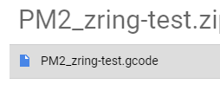
- Insert the included SD card into your computer
- Create a directory called “gcode” on the SD card
- Copy PM2_zring-test.gcode to the gcode directory created in last step
- Eject the SD card and insert it into Moai’s SD card reader
- Select Print from the Moai menu using the control knob
- Select gcode directory
- Select PM2_zring-test.gcode , and confirm to start printing

This print should last about 20 minutes and print at the B corner, see below: (disregard the four moai’s in this picture)
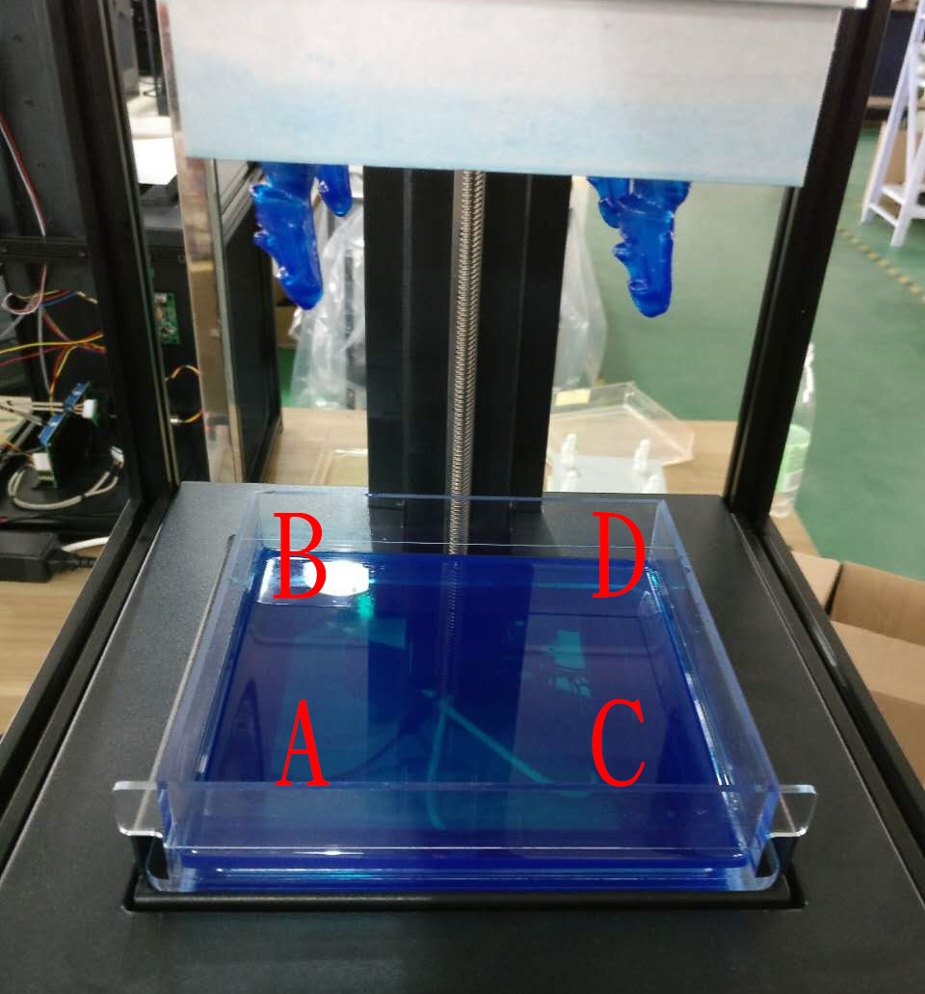
Couple scenarios can happen:

- Print is successfully, print sticks to the plate and looks like the ring below:
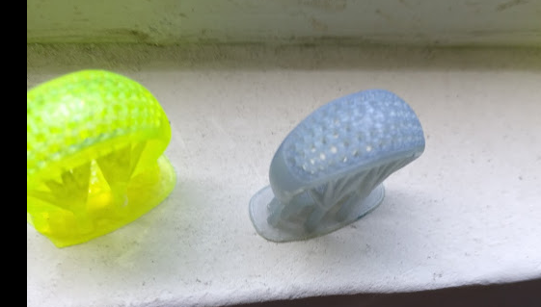

- Nothing is on the plate, a flattened piece can be found at the bottom of vat at the B spot
  - Check setting to make sure laser energy is at 58
  - The X/Y print speed is at 4

- A partial ring is printed and seems to broken off from the middle
  - Please increase laser energy to 59 and see if that works

- A ring is print it but seemed to have a side of it getting cut off
  - Please check to see if any cables are blocking laser.

Here is a link to an expanded troubleshooting chart.
https://atlas.mindmup.com/peopoly/moai_trouble_shooting/index.html

If it doesn’t work. Please redo leveling and make sure you follow the steps.

